RESTAURANT CUSTOMER SATISFACTION PROJECT REPORT
MACHINE LEARNING & EXCEL DASHBOARD
PROJECT

PROJECT REPORT BY
CLARE GRACE P.R

DATA ANALYST

UNDER THE GUIDANCE &SUPERVISION OF
MISS AMRITHA

Palakkad, Kerala, 678702



INTRODUCTION
ABSTRACT
OBJECTIVE
METHODOLOGY
DATASET OVERVIEW
DATA ANALYSIS & EDA VISUALS
MODEL DEVELOPMENT & RESULTS
DASHBOARD OERVIEW
CONCLUSION & FUTURE SCOPE

1. INTRODUCTION
In today’s competitive restaurant industry, customer satisfaction plays a crucial role in business success. Restaurants must understand customer preferences, service quality perception, and overall dining experience to maintain loyalty and improve profitability.
With the advancement of data analytics and machine learning, businesses can analyse customer feedback and operational data to predict satisfaction levels. By identifying key factors influencing customer satisfaction, restaurants can make data-driven decisions to enhance service quality, pricing strategies, and customer experience.
This project focuses on analysing restaurant customer data and building predictive machine learning models to determine overall customer satisfaction based on various influencing factors.

2. ABSTRACT
This project aims to implement machine learning techniques to predict restaurant customer satisfaction based on customer rating on service ,food and ambience attributes. The dataset includes features such as food quality, service quality, cleanliness, price fairness, ambience, waiting time, staff behaviour, menu variety, and recommendation likelihood.
After performing data preprocessing, encoding categorical variables, handling missing values, and conducting Exploratory Data Analysis (EDA), multiple machine learning models were developed and evaluated.
Among the tested models — Logistic Regression, Random Forest, and other classification algorithms — the Random Forest model provided the best predictive performance due to its ability to handle complex feature interactions.
Additionally, a dashboard was developed to visualize customer satisfaction trends, service quality impact, and overall performance indicators. The results highlight that food quality, service quality, and price fairness are major factors influencing customer satisfaction.

3. OBJECTIVES
The main objectives of this project are:
- Analyse the restaurant customer dataset to identify factors affecting customer satisfaction.
- Perform Exploratory Data Analysis (EDA) to discover patterns and trends.
- Build and compare machine learning models to predict customer satisfaction.
- Identify key features contributing most to customer satisfaction.
- Develop an interactive dashboard to visualize insights.
- Provide actionable recommendations for improving customer experience.

4. METHODOLOGY
Step 1: Data Collection
- Dataset sourced from kaggle Restaurant Customer Satisfaction(CSV format).
- Includes demographic, service-related, and behavioural features.
Step 2: Data Preprocessing
- Checked and handled missing values.
- Encoded categorical variables (Gender, Visit Frequency, Preferred Cuisine, Time Of Visit, Dining Occasion, Meal Type).
- Standardized/normalized numerical variables where necessary.
- Created feature matrix and target variable.
- Split dataset into training and testing sets.
Step 3: Exploratory Data Analysis (EDA)
- Analysed distribution of satisfaction levels.
- Age distribution of customers
- Distribution of gender according satisfaction
- Rating Distribution
- Used visualizations such as:
  - Histograms
  - Bar charts
  - Sub plots

Step 4: Model Building
Applied Machine Learning Algorithms:
- Logistic Regression
- Decision Tree
- Random Forest Classifier
- KNN
Evaluation Metrics Used:
- Accuracy Score
- Confusion Matrix
- Precision
- Recall
- F1 Score
Step 5: Dashboard Development
Developed dashboard (Excel/ Streamlit) showing:
- Overall Satisfaction Rate (KPI)
- Average Food Quality Rating
- Average Service Quality Rating
- Satisfaction by Gender
- Satisfaction by Dining Occasion
- Impact of Waiting Time on Satisfaction

5. DATASET OVERVIEW
- Dataset Name: Restaurant Customer Satisfaction
- File Format: CSV
- Total Records:1500
Key Features:
Gender, Income, Visit Frequency, Average Spend, Preferred Cuisine ,Time of Visit, Group Size, Dining Occasion, Meal Type, Loyalty Program Member, Wait Time, Service Rating, Food Rating, Ambiance Rating, High Satisfaction
Target Variable:
- High Satisfaction

6. DATA ANALYSIS & EDA VISUALS
Key Observations:
- Food Quality shows strong positive correlation with Satisfaction.
- Service Quality significantly impacts Recommendation Likelihood.
- Long Waiting Time negatively affects satisfaction levels.
- Customers who rated Price Fairness high were more likely to recommend.
- Cleanliness and Staff Behaviour strongly influence repeat visits.
Visualizations Used:
- Satisfaction Distribution Chart(Bar chart
- Gender vs customer Satisfaction(column chart)
- Age Distribution of Customers(Histogram)
- Ratings Distribution(Subplot-bar chart)

7. MODEL DEVELOPMENT & RESULTS
Models Implemented:
- Logistic Regression
  - Used as a baseline classification model.
- Decision Tree Classifier
  - Captures non-linear patterns but prone to overfitting.
- Random Forest Classifier
  - Best-performing model with higher accuracy and stability.
- KNeighborsClassifier
- Distance-based and features with larger values can dominate the distance calculation.

Best Model: Random Forest Classifier
- Handles non-linearity well
- Manages feature interactions effectively
- Provides higher accuracy
- Accuracy:0.87

8.DASHBOARD OVERVIEW

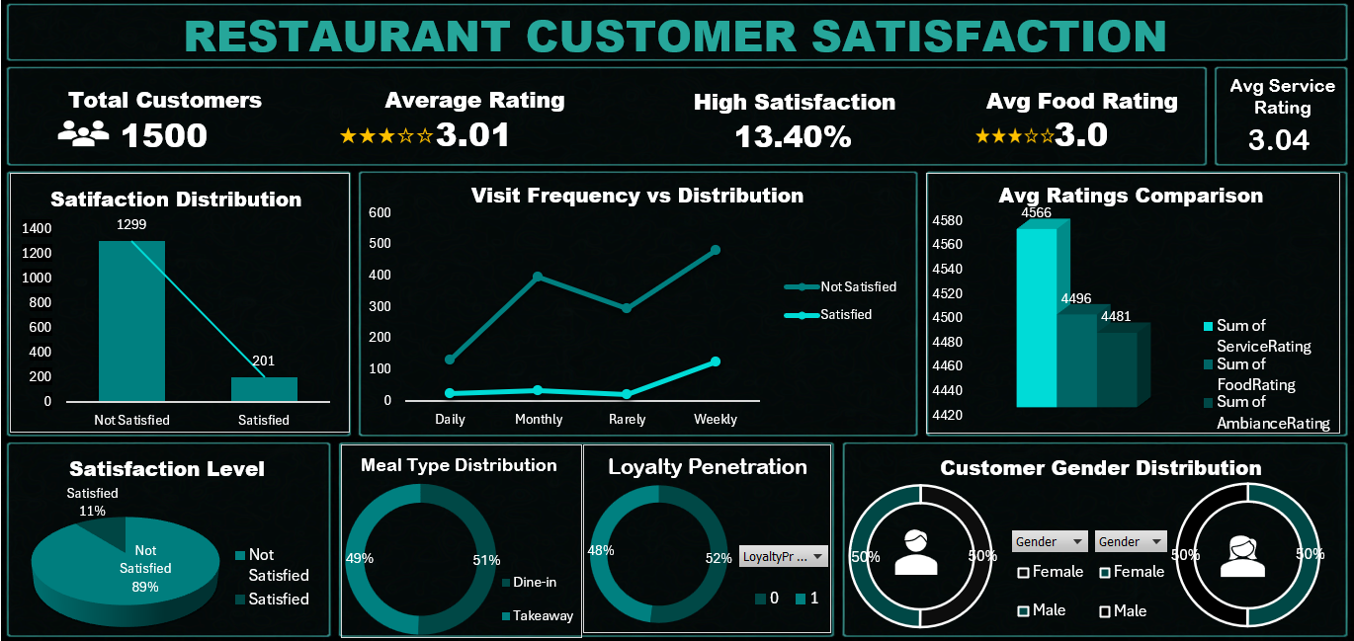
The dashboard presents interactive insights for business decision-making.
KPIs Displayed:
- Total Customers
- Average Rating
- High Satisfaction
- Average Food Rating
- Average Service Rating
Visual Components:
- Satisfaction Distribution
- Visit Frequency vs Distribution
- Average Rating Comparison
- Meal type Distribution
- Loyalty Penetration
- Gender Distribution

8. CONCLUSION & FUTURE SCOPE
Conclusion:
This project successfully demonstrates how machine learning can be applied to predict restaurant customer satisfaction based on dining experience factors.
The analysis identified Food Quality, Service Quality, Price Fairness, and Staff Behaviour as the most influential factors affecting satisfaction.
Among the implemented models, the Random Forest Classifier achieved the best performance due to its ability to handle complex patterns in customer behaviour data.
The integration of predictive modelling with dashboard visualization provides actionable insights for restaurant management to enhance customer experience and increase retention.
Future Scope
- Integrate real-time customer feedback systems.
- Deploy the model as a web application for live predictions.
- Incorporate sentiment analysis from online reviews.
- Use advanced models such as XGBoost or Neural Networks.
- Implement automated retraining pipelines for improved scalability.

